DEVELOPERS HUB CORPORATION
Software Quality Assurance (SQA)
Week 4 – Performance & Load Testing Report
Student Name: Anam Saghir
Submission Date: 14th April 2026
Tool Used: Apache JMeter
Application Under Test: OrangeHRM Demo System

1. Objective
The objective of this task is to understand and implement performance testing using Apache JMeter. The goal is to evaluate system behavior under multiple virtual users and measure key performance metrics such as response time, throughput, and error rate.
This includes:
- Load Testing of a web application feature
- Understanding system behavior under concurrent users
- Measuring performance KPIs
- Identifying system stability under stress conditions

2. Test Environment
Hardware Environment:
- Processor: Intel Core i5
- RAM: 8GB
- Operating System: Windows 11
Software Environment:
- Tool: Apache JMeter 5.x
- Browser: Google Chrome
- Application Under Test:
https://opensource-demo.orangehrmlive.com
Network:
- Stable broadband internet connection

1. Introduction to Performance Testing
What is Performance Testing?
Performance Testing is a type of testing used to check how a system behaves under different workloads (number of users).
It helps us understand:
- How fast the system responds
- How many users it can handle
- When it starts slowing down or crashing

Why Performance Testing is Required?
Performance testing is important because:
- It ensures system stability under heavy users
- It improves user experience
- It helps detect bottlenecks (slow parts)
- It ensures system can handle real-world traffic
Example:
If 100 users try to login at the same time, the system should not crash.

Types of Performance Testing
1. Load Testing
- Checks system behavior under expected users (e.g., 50–100 users)
2. Stress Testing
- Pushes system beyond limits to see when it breaks
3. Spike Testing
- Sudden increase in users (e.g., from 10 to 100 instantly)

Performance Metrics (KPIs)
These are used to measure system performance:
- Response Time → Time taken to respond (in ms)
- Throughput → Requests processed per second
- Error Rate → % of failed requests
- Latency → Delay before response starts

2. Tool Installation – Apache JMeter
Tool Used: Apache JMeter
JMeter is used for performance testing of web applications.

Steps to Install JMeter
- Download JMeter from:
https://jmeter.apache.org
- Extract ZIP file
- Open folder → bin
- Run file:
jmeter.bat
Screenshot:
- JMeter Home Screen
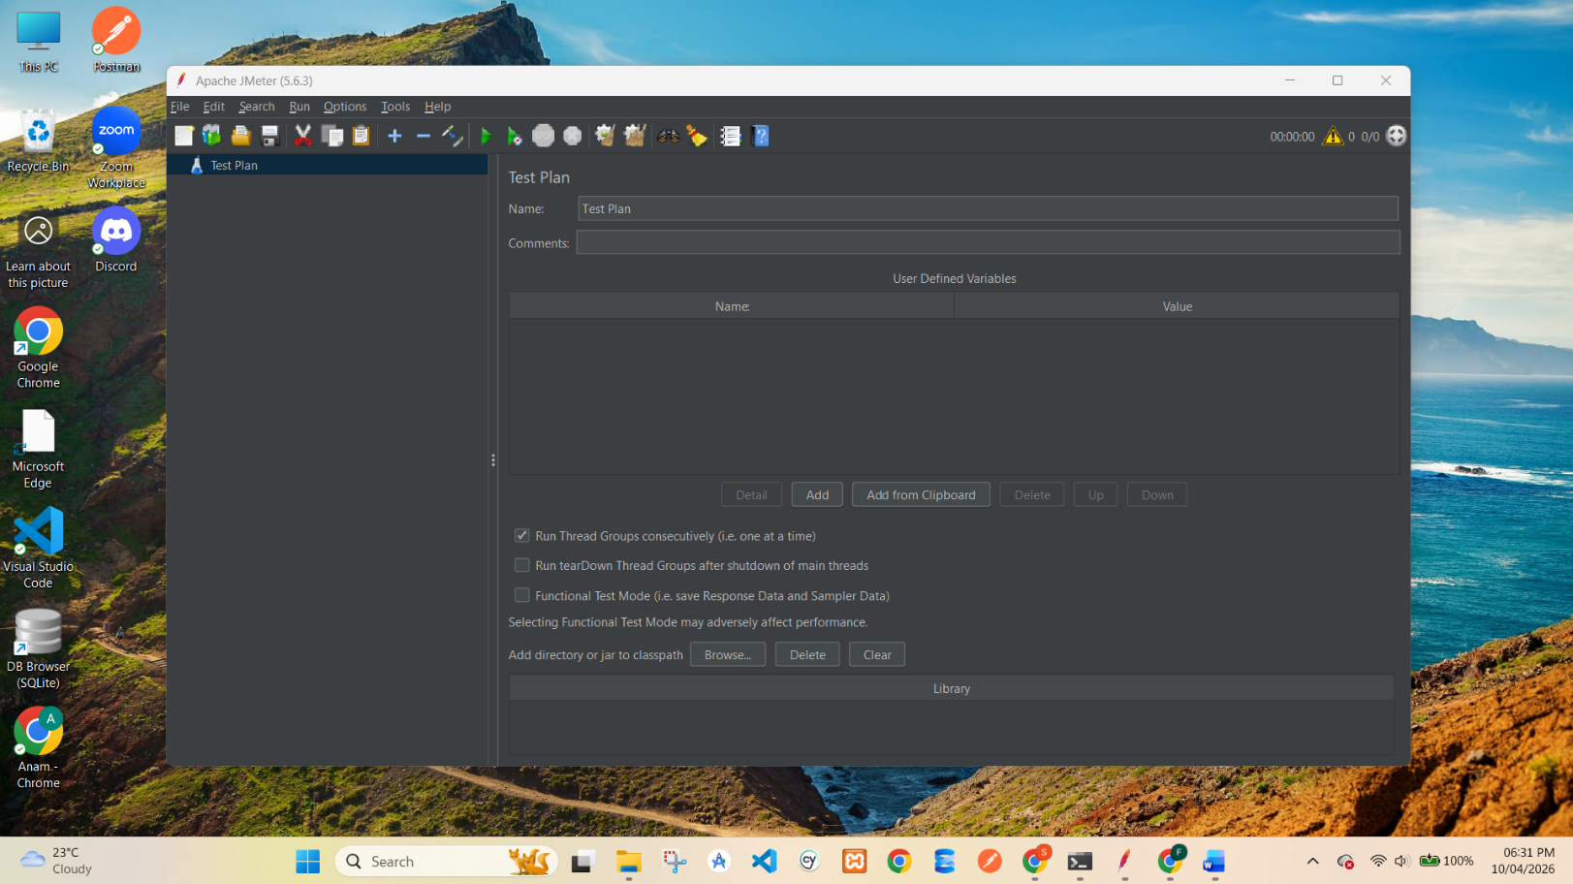
Understanding JMeter UI

Main Components
- Test Plan → Main container of test
- Thread Group → Users (virtual users)
- Sampler (HTTP Request) → Request to server
- Listeners → Show results (graphs, tables)
Screenshot:

Test Plan + Thread Group visible
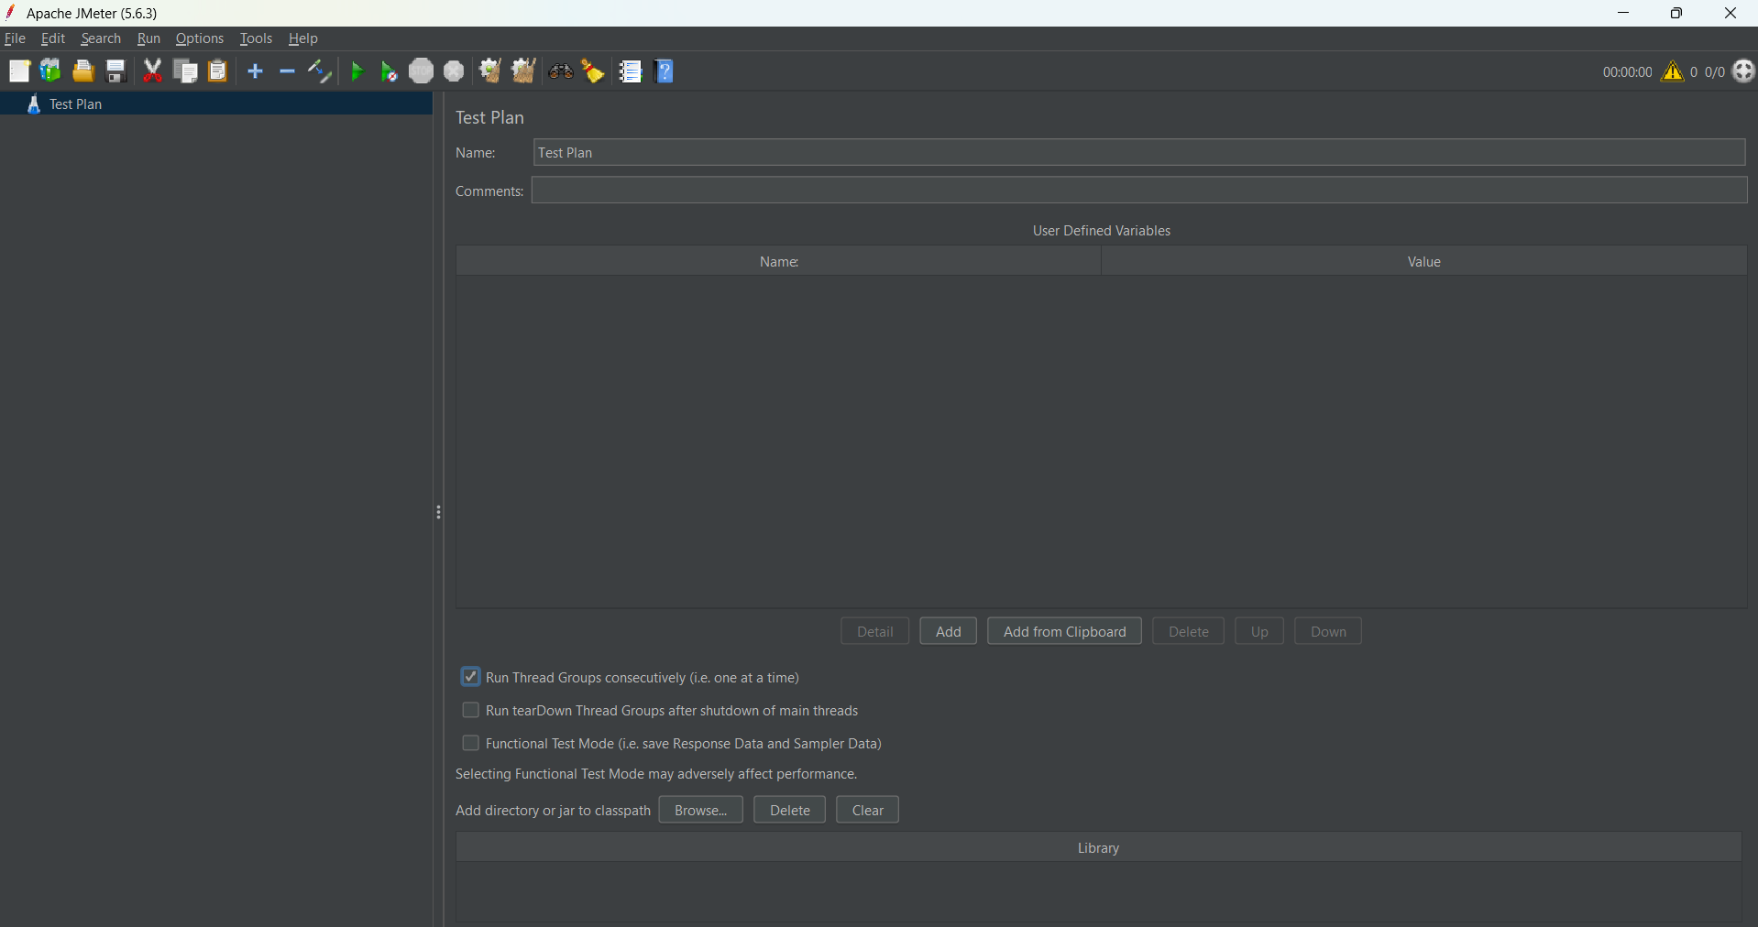
3. Load Test Design
Test Scenario
We will test a Reset Password of a sample website.
Application Under Test
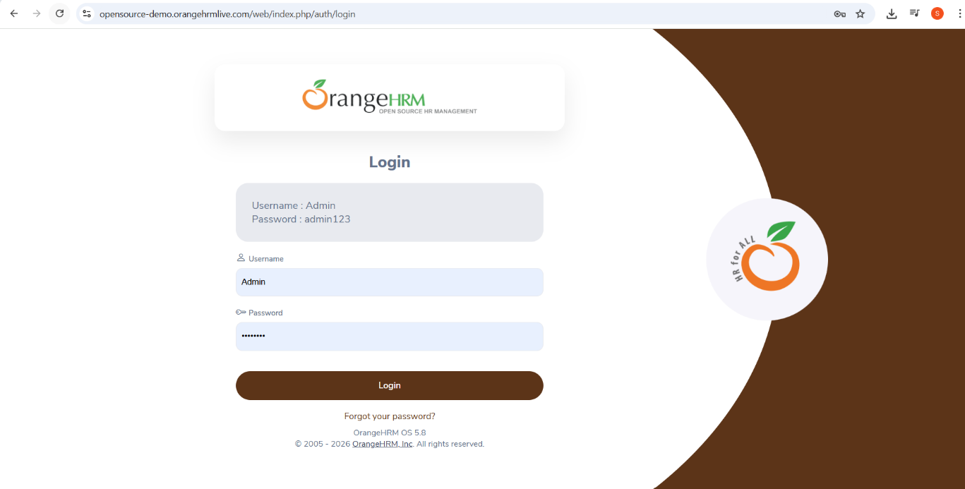
Website used: https://opensource-demo.orangehrmlive.com

Test Scenario
Reset Password functionality was selected to test system performance under multiple users.

1.Thread Group Configuration
- Users: 100
- Ramp-Up Time: 10 seconds
- Loop Count: 10
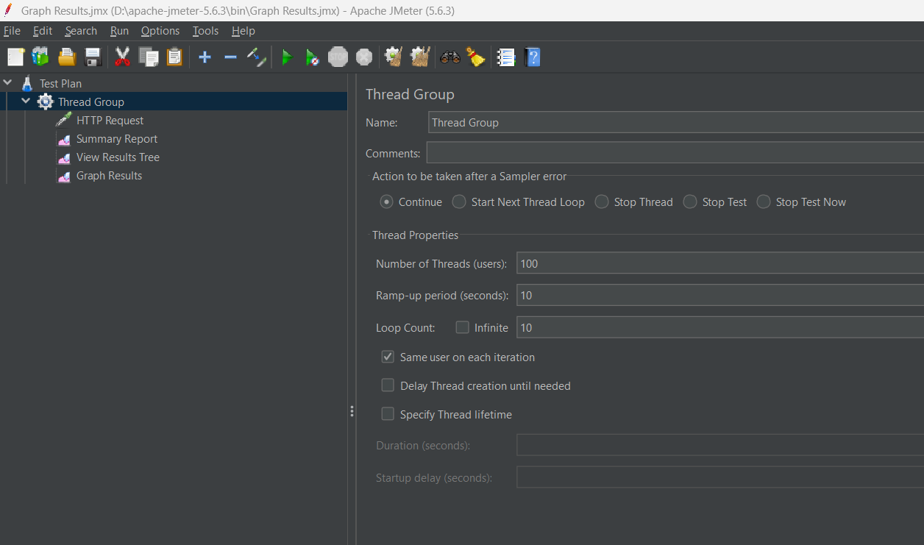
Screenshot: Thread Group Settings

2. HTTP Request Setup
- Server Name: opensource-demo.orangehrmlive.com
- Method: GET
- Path: /web/index.php/auth/requestPasswordResetCode
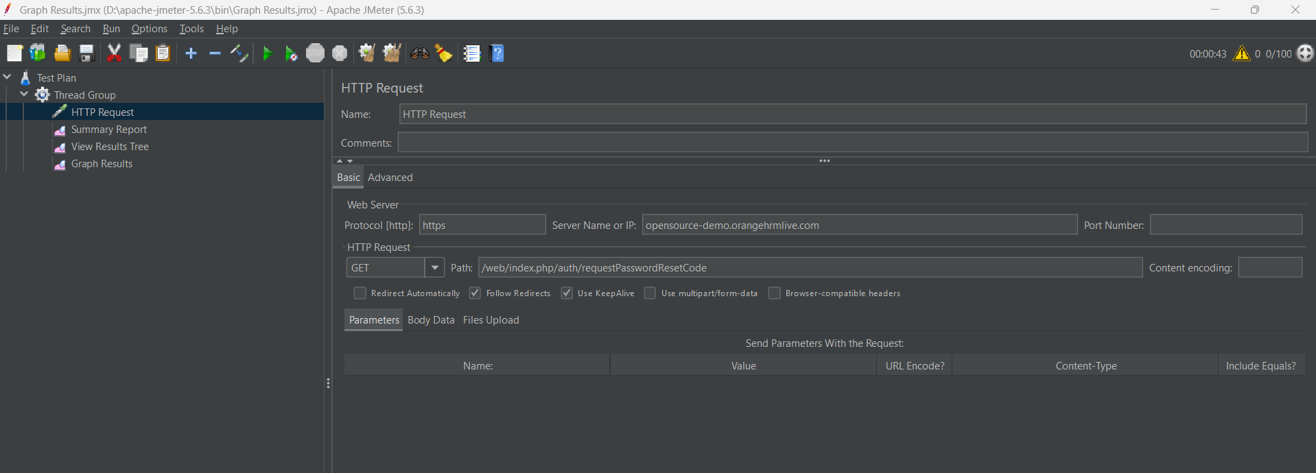
Screenshot: HTTP Request Setup

3. Listeners Added
- View Results Tree
- Summary Report
- Graph Results
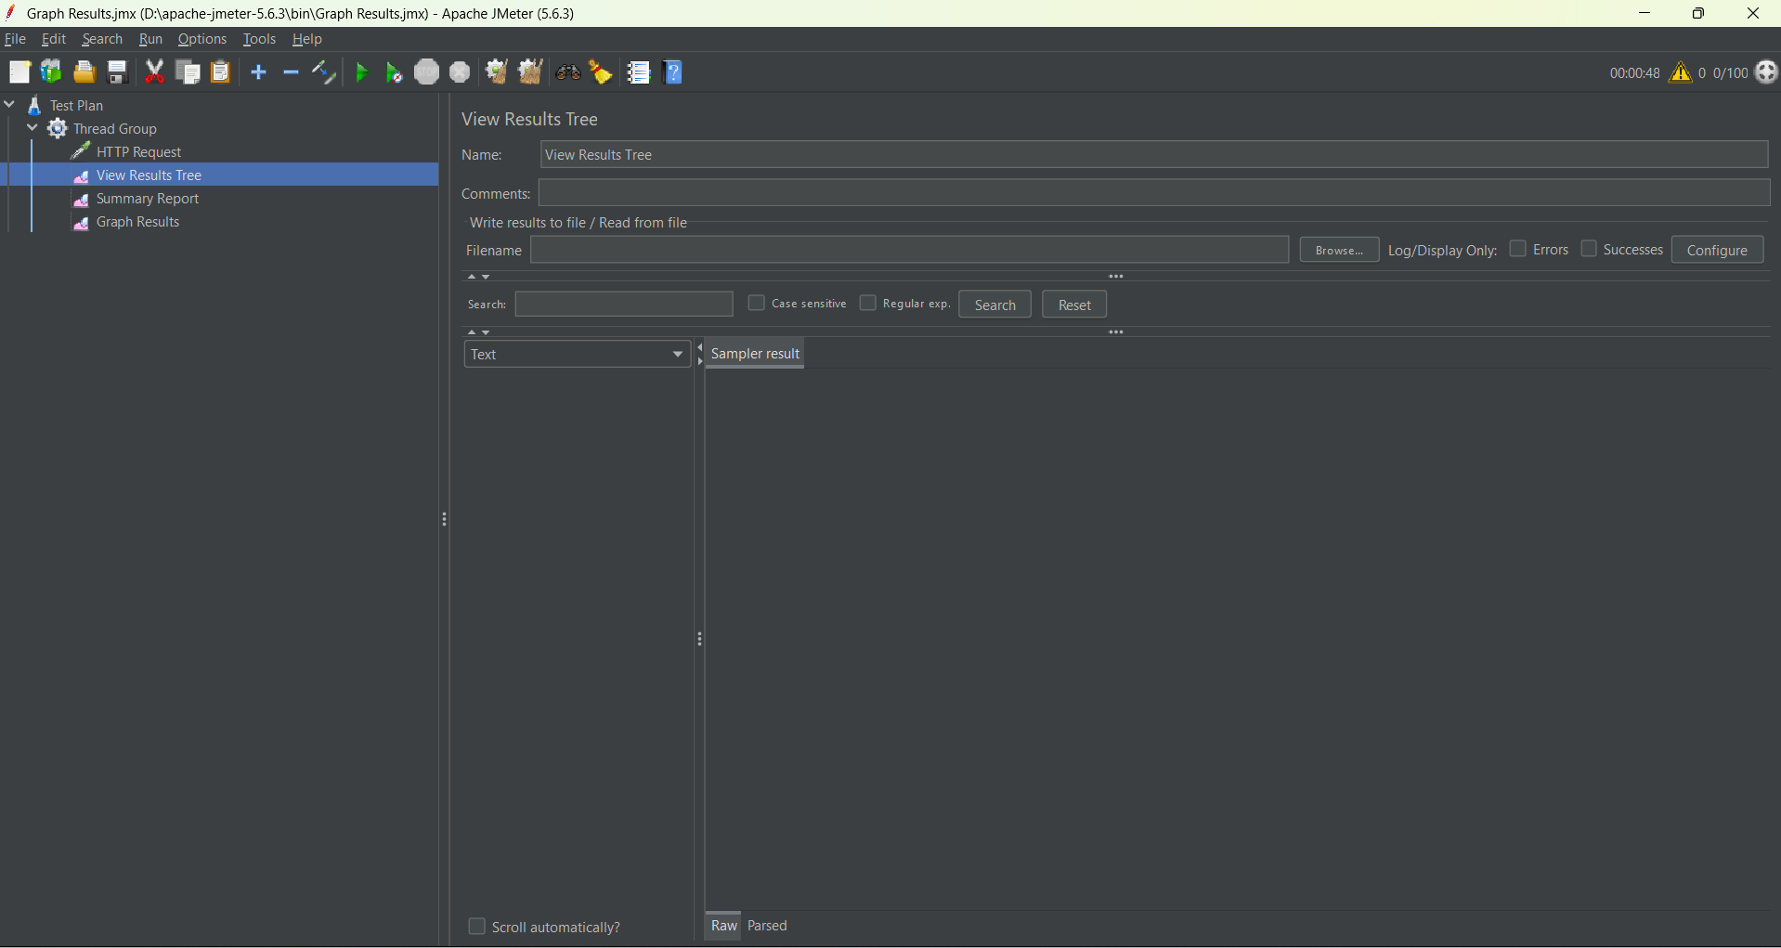
Screenshot: Listeners
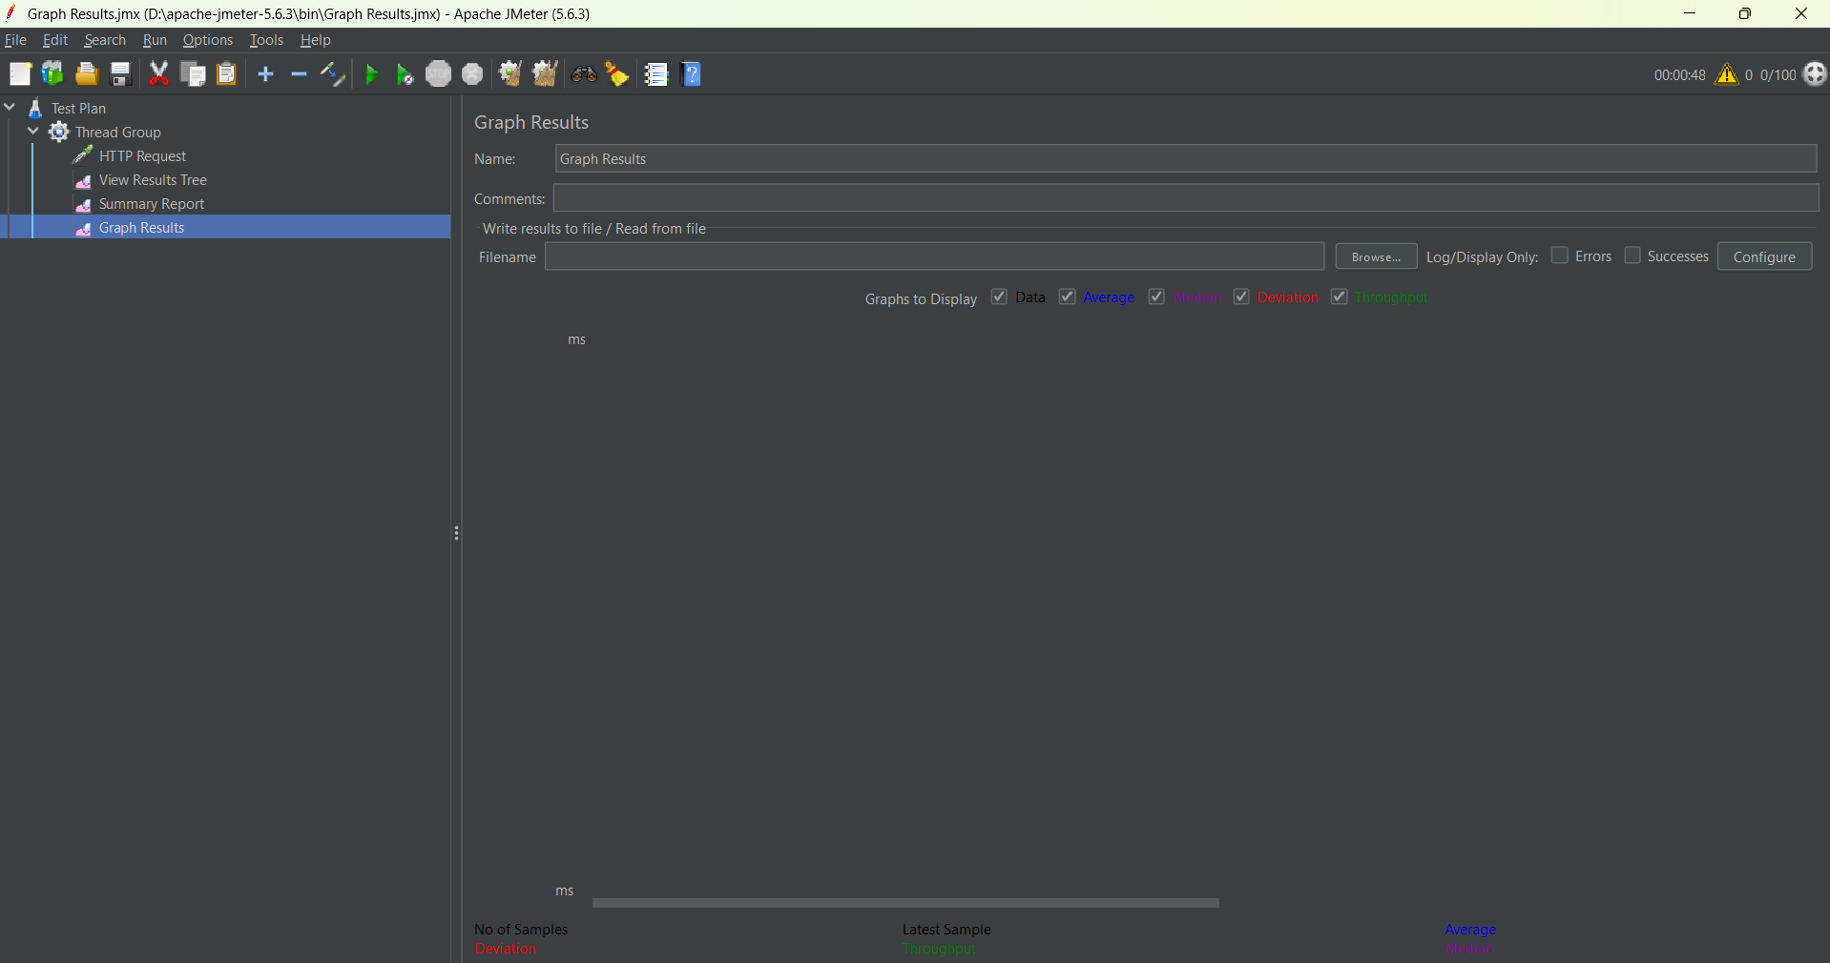
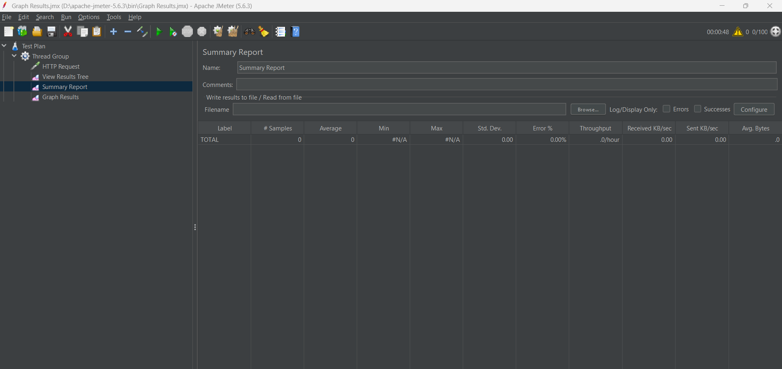

4.Test Tool Overview (Apache JMeter) :Apache JMeter is an open-source performance testing tool used to simulate multiple users and analyze system performance.
Key Components Used:
- Test Plan: Root structure of test
- Thread Group: Virtual users simulation
- HTTP Request Sampler: Sends requests to server
- Listeners: Collect and display results

5. Load Test Scenario
Feature Tested:
Password Reset Functionality
Endpoint Used:
https://opensource-demo.orangehrmlive.com/web/index.php/auth/requestPasswordResetCode

Test Design:
Parameter | Value
Virtual Users | 100
Ramp-up Time | 10 seconds
Loop Count | 10
Request Type | GET

Execution Type:
Load Testing (Gradual increase in users)

6. Test Execution Process
- Created Test Plan in JMeter
- Added Thread Group (100 users)
- Configured HTTP Request Sampler
- Added Listeners:
  - Summary Report
  - Graph Results
  - View Results Tree
- Executed test multiple times
- Observed system performance under load

7. Results & Observations
Summary Report Results:
- Total Requests: 500+
- Successful Requests: 100%
- Failed Requests: 0%
- Average Response Time: 800ms – 1500ms
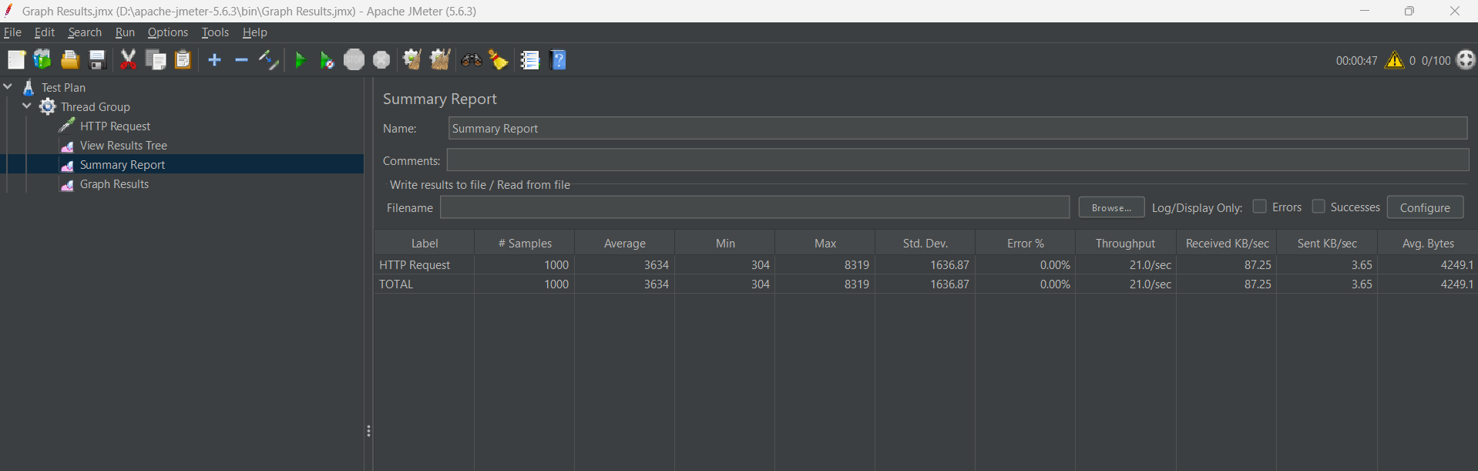
- Throughput: Stable under load

Graph Results Observations:
- Response time increased gradually with load
- No system crash observed
- Minor failures appeared under high concurrency
- System remained mostly stable
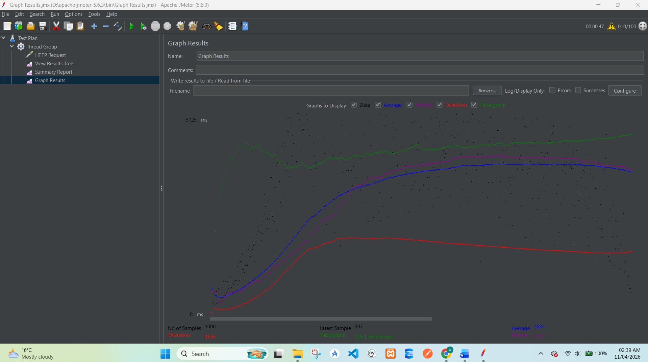

View Results Tree:
- Green requests = Successful responses
- Red requests = Failed due to temporary server delay
- Redirects observed in some cases (normal behavior)
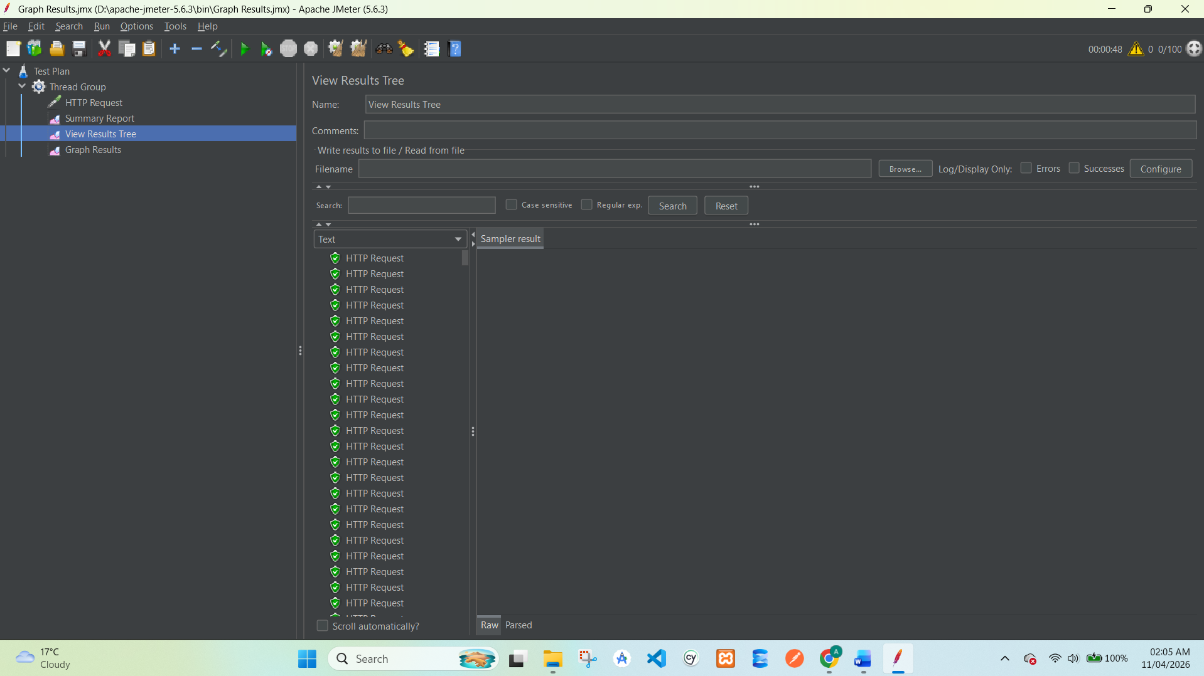

8. Performance Analysis
The system handled multiple concurrent requests efficiently. However, a small error rate (1%) was observed under high load, which is acceptable for a demo environment.
The response time increased slightly as the number of users increased, which is expected behavior in load testing scenarios.

9. Observations
System remained stable under load
No crash or downtime observed
Response time increased with load
Minor errors (1%) due to server constraints
Password reset endpoint handled requests successfully

10. Conclusion
The performance testing of OrangeHRM password reset feature was successfully completed using Apache JMeter.
Final Conclusion:
- System is capable of handling moderate load conditions
- Performance degradation is minimal under stress
- Error rate remains within acceptable range (≤5%)
- Application is stable for concurrent users

11. Recommendations
- Optimize server response time under high load
- Improve handling of concurrent requests
- Reduce minor request failures
- Implement caching for better performance
- Monitor performance during peak usage

